Social Studies 11- Identity
Canadian Identity
Discuss the following with a partner: What makes up a nation’s identity?
Brainstorm a list of features that make up China’s or Korea’s (or any other countries) national identity:
-
-
-
-
Discuss the following with a partner: Can a country have more than one national identity? Could this be a cause for conflict? Provide some examples
Brainstorm with a partner what you think the features of Canada’s national identity are:
-
-
-
-
-
-

National Identity as expressed through national flags
The Union Jack- Canada’s national flag until 1914
Which national identity did this flag represent?

Which groups in Canada may have felt excluded by this flag, why?

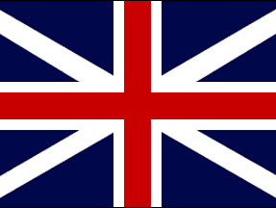

The Red Ensign- Canada’s flag from 1914- 1964
Has this flag added any changes to Canada’s national identity, explain?

Would this design have satisfied all Canadians?

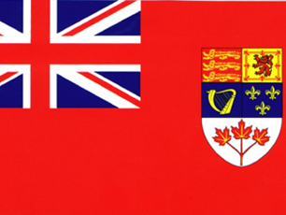

The Maple Leaf- Canada’s flag from 1965- present
What kind of national identity is represented by this flag?

Would this design have satisfied all Canadians?

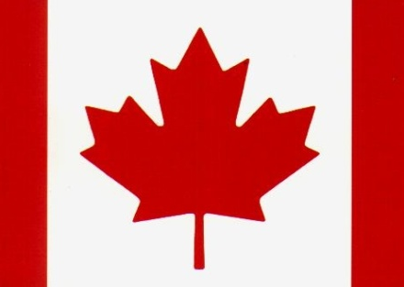

Personal Identity:
To be Mr. Austen means to be a son, a brother, a fiancé, a man, a hockey player, a teacher and a traveler.

To be ___________________ means to be_________________________________________________

____________________________________________________________________________________

National Identity
To be Canadian means to be compassionate, tolerant, multicultural, have a short history, be peacekeepers, hockey fans and nature lovers.

To be _________ means to be ___________________________________________________________

_____________________________________________________________________________________

With your partner, discuss the following situation:
A teacher comes to China to work. While here, he and his Canadian wife have a child. The child grows up in China, goes to Chinese public school, learns to speak Chinese fluently, prefers chopsticks to a knife and fork and only visits Canada on vacation.
Is this child Canadian or Chinese? Be prepared to take sides and defend your opinion.

Identity Evolves
Identity, national or personal is something that is always changing. With a partner, discuss what your grandparents’ sense of national identity was when they were your age. Make a list of the characteristic below.
Intro to Canada & Canadian Symbols
Directions: As an introductory activity look at the photos listed below and discuss the questions with your partner.
1. Pages 141 and 148: Notice the Avro Arrow and the Canadarm. How/why are technological advances important to a nation? What technologies is your nation proud of?

2. Page 179: What do you know about Terry Fox? Are heroes important to a nation? Who are your national heroes?

3. Pages 155-6: Peacekeeping is part of Canada’s international image. How does the world see your nation? How do you know?

4. Page 149: Some say this was Canada’s greatest moment in sports. Why would this be important to Canadians? What is your country’s greatest moment in sports?

5. Page 199: Why does Canada have a Queen? Why is she riding in a horse-drawn carriage and not a car? Does your country keep any traditions like this?

6. Page 293: What do Canadians look like? What does this photo say about Canada?

7. Page 444: The canoe is a Canadian symbol and enjoying wilderness is part of Canadian culture. What impression does this photo give you of Canada? Does this activity occur in your country?

Considering the photos and what you learned in SS10, write a paragraph that describes your impression of Canada.
________________________________________________________________________________________________________________________________________________________________________________________________________________________________________________________________________________________________________________________________________________________________________________________________________________________________________________________________________________________________________________________________________________________________________________________________________________________________________________________________________________________________________________________________________________________________________________________________________________________________________________________________________________________________________________________________________________________________________________________________________________________________________________________________________________________________________________________________________________________________________________________________________________________

