Social Studies 11- World War Two
Canada Declares War
Vocab:
Crown corporation- government owned and operated companies, factories (transportation system etc.)
Mobilize- put resources manpower into action
Isolationist- not wanting to get involved in foreign affairs, or conflicts

Read Canada Declares War on pp. 101-102

Discuss with a partner why Prime Minister King pursued an isolationist policy for Canada in the late 1930s?

- When did Canada declare war on Germany?

- How did this declaration differ from World War One?

- What promise did King make to Quebec, why?

Read Mobilizing Canada’s Resources

- What evidence indicates that Canada’s military was unprepared for another world war?

- What was the reaction of Canadians to the declaration of war and how did this differ from World War One?
World War One reaction | World War Two reaction

Read The British Commonwealth Air Training Plan and Total War on pp. 104-5

- What was the British Commonwealth Air Training Plan?

- What was the main reason Prime Minister King decided to host this program?

Describe the concept of “total war”
1940 Ogdensburg Agreement
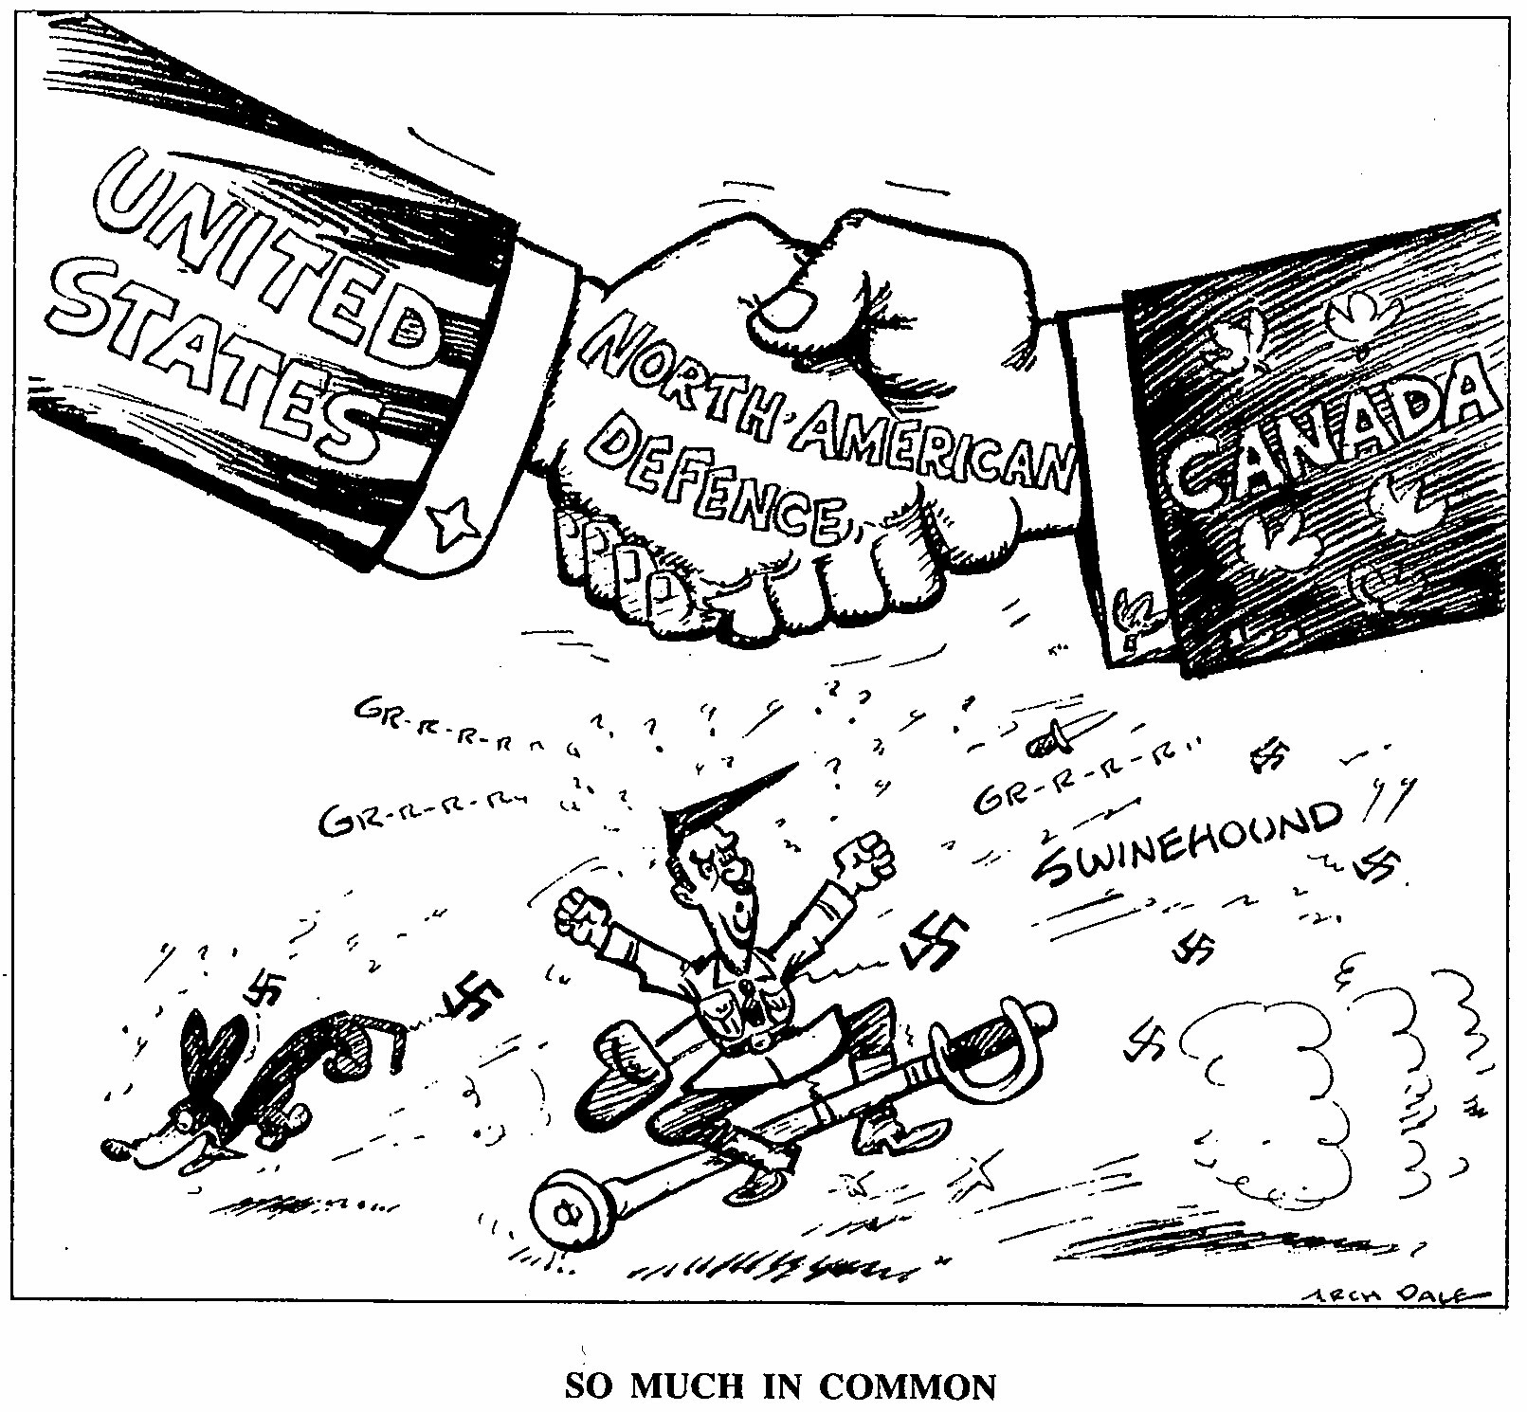
Examine the cartoon at left with a partner and
discuss the following:

- What is the cartoon’s message?

- Who is the figure below the two hands shaking?

- What does the caption “so much in common mean”?

