Conscription

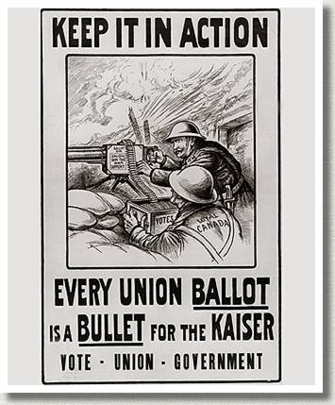

* Read pages 39 and define the following words:

Conscription -

Military Service Act –

Conscientious Objector -

* In 1917, Prime Minister Robert Borden called an election over the conscription issue. Read pages 40-41 and define the following two changes he made that helped him win the election:

Military Voters Act -

Wartime Elections Act -

Violence in Quebec
On August 28, conscription became law and was followed by two days of violence in Montreal. Store windows were smashed and tramway rails ripped up. One hundred and fifty policemen were called in to disperse the crowd, and four were wounded, along with two demonstrators. The following evening, a demonstrator was killed in Philips Square.
On Easter weekend 1918, a 23 year-old man named Joseph Mercier was arrested at a Quebec City bowling alley, for not having his conscription registration papers on him. The incident sparked retaliation: a crowd looted the offices of the army registrar, pitched files out in the snow and smashed the windows of English shops.
Paragraph Response:
How did the conscription issue divide Canada and affect French-English relations?
__________________________________________________________________________________________________________________________________________________________________________________________________________________________________________________________________________________________________________________________________________________________________________________________________________________________________________________________________________________________________________________________________________________________________________________________________________________________________________________________________________________________________________________________________________________________________________________________________________________________________________________________________________________________________________________________________________________________________________________________________________________________________________________________________________________________________________________________________________________________________________________________________________________
Canada: A People’s History DVD — 11 minutes

Directions: Imagine you and your classmates are all young Quebeckers. Make a group of 3-4 people, and discuss with your classmates how you feel about conscription and WWI.

Assignment After your discussions, write a letter to Prime Minister Robert Borden about your feelings towards the Military Services Act. You can be for conscription, or against it. The letter is due next class.

24 Sussex Drive, ____________ , 1917
Ottawa, Ontario, Canada
K1A 0A3

Dear Prime Minister Borden,
__________________________________________________________________________________________________________________________________________________________________________________________________________________________________________________________________________________________________________________________________________________________________________________________________________________________________________________________________________________________________________________________________________________________________________________________________________________________________________________________________________________________________________________________________________________________________________________________________________________________________________________________________________________________________________________________________________________________________________________________________________________________________________________________________________________________________________________________________________________________________________________________________________________________________________________________________________________________________________________________________________________________________________________________________________________________________________________________________________________________________________________________________________________________________________________________________________________________________________________________________________________________________________________________________________________________________________________________________________________________________________________________________________________________________________________________________________________________________________________________________________________________________________________________________________________________________________________________________________________________________________________________________________________________________________________________________________________________________________________________________________________________________________________________________________________________________________________________________________________________________________________________________________________________________________________________________________________________________________________________________________________________________________________________________________________________________________________________________________________________________________________________________________________________________________________________________________________________________________________________________________________________________________________________________________________________________________________________________________________________________________________________________________________________________________________________________________________________________________________________________________________________________________________________________________________________________________________________________________________________

Sincerely,

______________________________

