The Evolving Nature of Canadian Identity
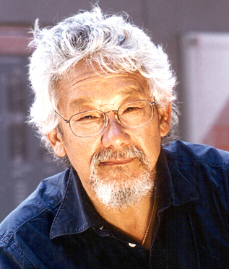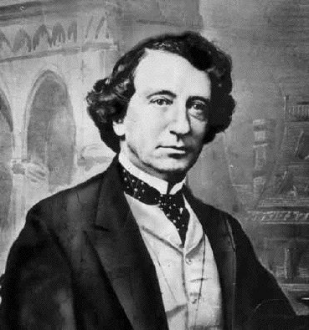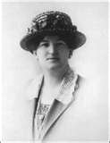
1867 – Canada became a nation.
(Ontario, Quebec, New Brunswick, Nova Scotia)
- Identity develops based on Fr/Eng/Scot/Irish /American culture
- – Manitoba and Northwest Territories joined Canada
1871 – BC joined Canada (Is promised a railway out west) – 1873 - PEI
1885 – CPR (Canadian Pacific Railway) is completed
  - Brings Easterners out West
1896 – European immigration accelerated (government helps)
1898 – Yukon became Canada’s second territory
1905 – Alberta and Saskatchewan created (enough settlers move West)
1914-1918 – WW1 (Canadians united to achieve one goal – win war)
- Canadians began to see themselves as distinct from the British (slowly developed identity) Ex. They are Canadian, not British.
1920`s – 1930`s – A new post-war identity was developing (cities and industry developing) Ex. Canadians become more urban and multicultural
- Canada started to dominate in hockey (creates pride)
- CBC (Canadian Broadcast Corporation) radio created
  - Helped unify the country)
1939 – 1945 – WW2 – Canada plays an important role in winning the war (created pride of being Canadian)
1949 – Newfoundland and Labrador joined Canada, becoming the 10th province
1950`s – 1960`s – Massive immigration increased multiculturalism
- TV replaces radio (Canadians start watching a lot of American TV)
- Students began to sing O`Canada instead of God Save the Queen
- Women took on more of an equal role
1965 – The Maple Leaf flag and O’Canada national anthem introduced
- Both are very Canadian!!
1968 – Official Language Act was passed (two founding languages and cultures “Bilingualism”
1971 – “Multiculturalism” policy designed to help Canadians of various ethnic backgrounds preserve their culture (Ex. First Nations)
- Up to the Present – Canadian identity continues to evolve...
  - Canada has become very modern, urban, industrial and strives for diversity and equality
1999 – Nunavut became Canada’s 3rd territory

