Social Studies 11- Law
The Court System
Vocab:
Judge- appointed official responsible for managing the courtroom and interpreting laws
Jury- 12 citizens decide the guilt or innocence of an accused person in serious criminal cases
Appeal- ask a higher court to hear the case again, attempt to get a new verdict

Read The Court System on pp. 277-78

- In which court are the most serious criminal cases heard?

- What is one of the main differences between criminal cases heard in lower courts and those heard in the highest court?

Discuss the following with a partner: Why do you think Jury trials are important for Canada’s democracy?

- On what grounds can an appeal to a higher court be made?

Read the Supreme Court of Canada
- How are Supreme Court Justices chosen?

- What kinds of cases does the Supreme Court of Canada deal with?

Summarize the main criticisms of the Supreme Court

How should Supreme Court Justices be chosen?
Option | Advantages | Disadvantages
Judges chosen by members of the government in power; holding office until retirement- current system
Judges chosen by government in power for a fixed term (10 years for example)

Potential judges scrutinized and approved by Parliament before being appointed (similar to American system)

Judges elected for a fixed term

Paragraph Question: How does Canada’s judicial system differ from China’s
______________________________________________________________________________________________________________________________________________________________________________________________________________________________________________________________________________________________________________________________________________________________________________________________________________________________________________________________________________________________________________________________________________________________________________________________________________________________________________________________________________________________________________________________________________________________________________________________________________________________________________________________________________________________________________________________________________________________________________________________________________________________

Canada’s Court System
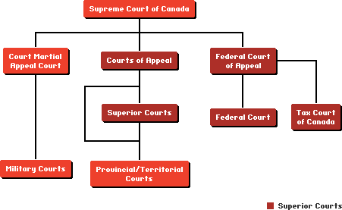
Supreme Court of Canada: The Supreme Court of Canada, our highest court, is based in Ottawa and consists of nine judges chosen to represent the country's regions (3 Ontario, 3 Quebec, 1 East, 2 West). The Supreme Court has the power to review lower-court rulings on any legal issue but limits cases to about 100 cases a year that involve issues of national importance.
Superior Courts: Each province and territory has two levels of superior court, one to hear trials and the other to hear appeals. Superior courts handle criminal offences, divorces, civil cases involving large amounts of money and Charter challenges, and review the decisions of some lower courts. In all other provinces and territories, it is called the Supreme Court. Rulings made by judges at the trial level can be appealed at the Court of Appeal, which is the highest court within the province or territory.
The Federal Court and the Federal Court of Appeal handle issues that arise under federal laws and appeals from the decisions of federal tribunals. The Tax Court deals specifically with disputes between taxpayers and the federal government over tax assessments. The Court Martial Appeal Court of Canada hears appeals from military courts which are known as "courts martial."
The federal government appoints and pays the superior court judges. Provinces and territories, however, provide courthouses and other facilities and support staff for the trial and appeal divisions of their jurisdiction's superior court.
Provincial and Territorial Courts: The provinces and territories appoint and pay judges who serve in the courts that form the lower tier of the court system. These courts have the power to deal with every criminal offence except the most serious offences, such as murder and piracy, and conduct pre-trial hearings, called preliminary hearings, in criminal cases destined for trial in superior court. They also handle violations of provincial laws. Provinces and territories have established Small Claims Courts to resolve civil actions involving small amounts of money. Youth Courts deal with young person’s between the ages of 12 and 18 charged with criminal offences.
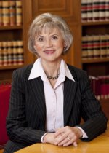
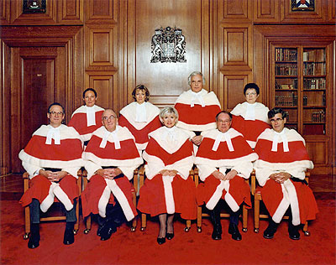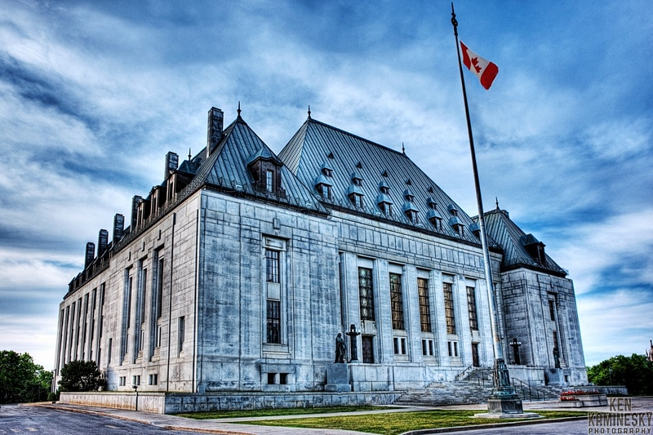
The Supreme Court Building, Chief Justice of Canada, Beverley McLachlin & the Supreme Court judges

