Social Studies 11- French-English relations
Constitutional Debates: Meech Lake, Charlottetown, and the 1995 Quebec Referendum
Vocab:
Accord- agreement to amend the Canadian constitution
Bloc Quebecois- federal separatist party

Read The Constitution Debate on p. 201.

- What did the new Conservative Prime Minister, Brian Mulroney promise French-Canadians?

Read The Meech Lake Accord on pp. 201-202

What did the Meech Lake Accord propose:

Describe some of the criticisms of the Meech Lake Accord:

- Why did the Meech Lake Accord fail?

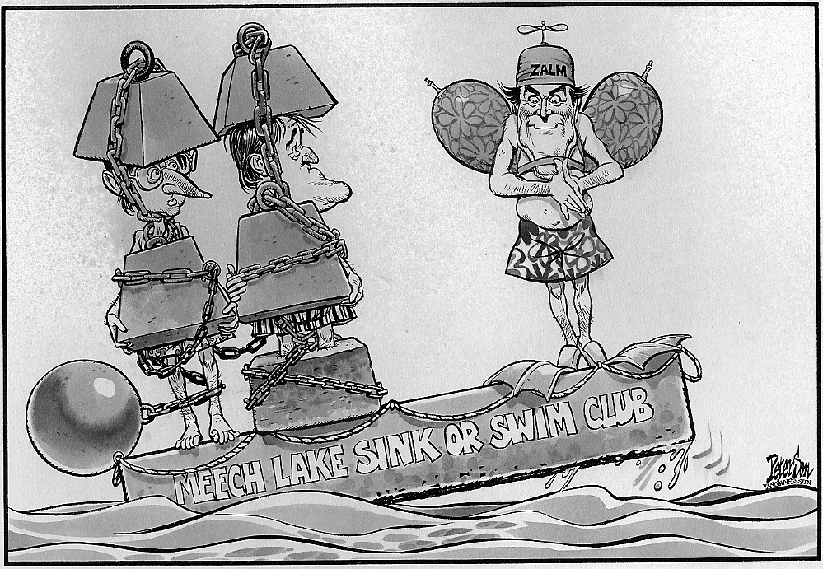
Discuss the message of the cartoon on the left
(from left to right: Constitutional affairs Minister Joe Clark, P.M. Brian Mulroney, and British Columbia Premier Bill Vander Zalm)

Read the Charlottetown Accord
What did the Charlottetown Accord offer:

- Why did the Accord fail?

Read Referendum of 1995 and After (pg. 203)
- What was the result of the 1995 referendum?
No__________, Yes ___________
Discuss the following with a partner:
Why do you think the result of the 1995 referendum was much closer than the 1980 referendum?

- What was the Clarity Bill?

Paragraph Response:
Compare and Contrast the approaches of Prime Ministers Pierre Trudeau and Brian Mulroney in dealing with Quebec and national unity.
________________________________________________________________________________________________________________________________________________________________________________________________________________________________________________________________________________________________________________________________________________________________________________________________________________________________________________________________________________________________________________________________________________________________________________________________________________________________________________________________________________________________________________________________________________________________________________________________________________________________________________________________________________________________________________________________________________________________________________________________________________________________________________________________________________________________________________________________________________________________________________________________________________________________________________________________________________________________________________________________________________________________________________________________________________________________________________________________________________________________
__________________________________________________________________________________________________________________________________________________________________________________________________________________________________________________________________________________________________________________________________________________________________________________________________________________________________________________________________
__________________________________________________________________________________________________________________________________________________________________________________________________________________________________________________________________________________________________________________________________________________________________________________________________________________________________________________________________
________________________________________________________________________________________________________________________________________________________________________________________________________________________________________________________________________________________________________________________________________________________________________

