Purpose: To understand the terms of the Treaties of Saint-Germain, Trianon, Sevres and Neuilly
To understand the effect these treaties had on geopolitics

- The Five Paris Treaties were all signed in Paris between 1919 and 1920, and were named after parts of the city.
Treaty of Saint-Germain (September 10th, 1919 - Austria) & Treaty of Trianon (June 4th, 1920 -Hungary)
- Austria and Hungary both became republics
- Austria was forbidden to unify with Germany (“anschluss”)
- Limited armed forces
- Czechoslovakia and Yugoslavia were created from Austro-Hungarian territory – self-determination?
- Territory given to Rumania, Poland, Italy
- Czechoslovakia had 3 million Germans living in Sudetenland area that had been taken
- Italy had 250,000 Germans in South Tyrol
- 3 million Hungarians were now part of Czechoslovakia, Rumania, and Jugoslavia
What is a republic?
A republic is a state in which the people are able to control the decision-making process. It is in direct opposition to a monarchy in which a small group of powerful people are able to make decisions.

Austria Hungary Before the Treaties  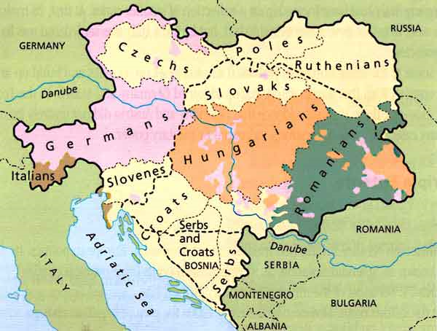 | Austria Hungary After the Treaties  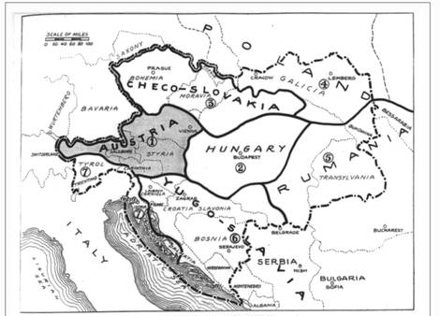
To what extent did these treaties represent Wilson’s self-determination mantra?
**When you see “To what extent” be sure to look at both sides of the argument**

Yes | No
Poles, Serbs, Croats, Czechs and Slovaks all given self-determination with the creation of Poland, Czechoslovakia and Yugoslavia from A-H land. | 3 Million Germans in Sudetenland, 250 000 Germans in South Tyrol, 3 million Hungarians were now in other countries.

Conclusion:

Treaty of Sevres (August 10th, 1920 - Ottoman Empire/Turkey)
- The Ottoman Empire was demolished
- Greece got Eastern Thrace, formally part of Turkey
- Britain got League of Nations mandates of Cyprus, Palestine, Transjordan and Iraq
- Italy got Rhoads and the Dodecanese Islands
- France got League of Nations mandate of Syria
- The treaty resulted in a nationalist movement to overthrow the Sultan and negotiate a new treaty; the Sultan was overthrown in 1922
- New Treaty of Lausanne (1923) terms: Thrace returned to Turkey and limits on the military removed

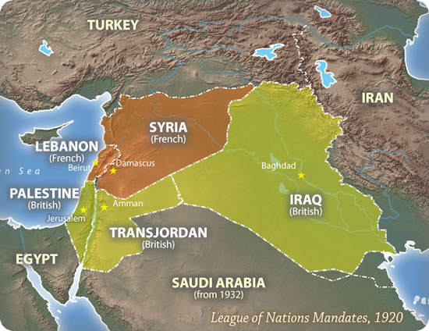 | Refer to Pg. 34  What particularily bothered the Turks about the Treaty?  Losing land to their long-term enemy, the Greeks  What is the significance of the renegotiation of the Treaty of Sevres?  It could be viewed as the first case of appeasement. It showed that the Allies would renogotiate instead of fighting another war. Displayed weakness.

The Treaty of Neuilly (November 27th, 1919 – Bulgaria)
- In this treaty, Bulgaria was punished for its role in the war with territorial losses, mostly to Jugoslavia.
Refer to Pg. 35 and answer the following questions:
Summarize the terms of the Young Plan.
German reparations went from $6.6 Billion to $2 Billion USD.

What does the Young Plan suggest about the terms of the Treaty of Versailles?
The Allied Powers realized that the terms of Versailles were too harsh and tried to lessen the burden on Germany.
Summarize the effects that the Treaties had on Austria-Hungary.
Lost vast amounts of land, lost millions of people, lost productive capabilities, felt alienated from the world.

Why was Italy still angry?
Italy felt cheated because, although it received some land, it did not receive all of the land that it had been promised in the Treaty of London in 1915. It left the conferences very angry.

The United States Rejects the Treaties and the League of Nations
- In 1919, upon returning to the USA and preparing for the 1920 election, Woodrow Wilson fell ill and suffered a stroke. His Vice President, Thomas R. Marshall, assumed the leader’s duties while Wilson recovered. He never did fully recover, and would die in 1924.
- In 1920 Wilson’s party the Democrats were swept out of power by the rival Republican Party, led by Warren Harding. This was a result of many domestic problems that had sprung up as the USA demobilized from Europe, and also an outright rejection of Wilson’s internationalist ideals.
- The Republican-controlled US government rejected the treaties and refused to sign them, and also refused to join the League of Nations. The country took an isolationist approach, and would not re-enter world affairs until it joined WW II in 1941.
Questions
What effect do you think these events will have on the success of the League of Nations?
When one of the strongest nations in the world refused to join, both the strength and legitimacy of the league were compromised.
Compare and contrast the regime changes in Turkey and the United States.
Similarities: both nations had radical changes in leadership shortly after the war, and the new leaders had different opinions than the old about the peace process.
Differences: The US used the political process to initiate change, while the Turks used violence.

Key Words
Saint Germain | Trianon | Sevres | Neuilly
Republic | Anschluss | Mandates | Palestine
Iraq | Transjordan | Cyprus | Syria
Treaty of Lausanne | Young Plan | 1920 Election | Isolationism
Sultan | 1920 Election | Internationalism
**Be prepared for a quiz next class**
Purpose: To assess the effects that the Paris Treaties had on geopolitics

- A geopolitical effect is an effect that is not limited to only one place, but instead affects politics in multiple places throughout the world. Although WWI was fought mostly in Europe, the treaties that created the peace affected many places throughout the globe, including Europe, North America, the Middle East, and Oceania.
Europe | N. America | Middle East | Oceania
- Geography  - Politics  - Anger | - Increased autonomy for Canada  - US politics  - US foreign policy | - Geography  - Turkish Politics  - Imperialism? | - Geography (think mandates)

- Because the war and its resulting peace terms affected 4 major areas of the world, it can safely be said that the Paris Treaties represent a geopolitical event. Write a paragraph arguing this point using only the space on the other side of this page.

